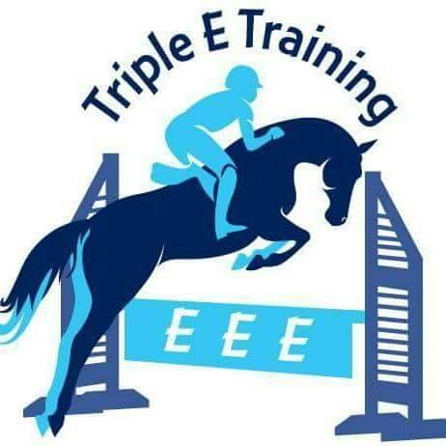

Item Personalization Color Size Price
 | #L317 Ladies soft shell jacket |  | Black |  | $76.00
 | #Y317 Childs soft shell jacket |  | Black |  | $72.00
 | #L325 Ladies soft shell vest |  | Black |  | $74.00
 | Ladies Hat | N/A low profile, non structured | Light Blue |  | $14.00
 | Mens Hat | N/A medium profile, non structured | Black |  | $14.00

Check #:_____________ Or cash received:________ _________ Total:$_________________

Name:_______________________________________________________________________
Address:_____________________________________________________________________
Phone & E-mail:_______________________________________________________________________________________
Special Instructions:___________________________________________________________

- Items must be paid in full at time order is placed, unless other arrangements have been made.. Check or cash. Please make checks payable to FHCE.
- Payments can now be made with credit/debit card or PayPal through PayPal Invoicing. E-mail me your order and I will send you a PayPal invoice to your e-mail, you will then have the option to pay with a credit or debit card or through your PayPal account.
- Please print clearly for any personalization. Names will be embroidered as they are written above. Letters wrote capitalized will be embroidered with capitals. Letters written with lower case will be embroidered with lower case.
- Orders generally take 2 weeks to be completed. Holiday Season may take longer.

* Please check spec sheets for sizing information.

Any questions: Please email or call Leslie Seidel 856-769-0696 fhce@hughes.net
Web-Site: www.fh-ce.com FB: www.facebook.com/fhcembroidery
No Refunds or exchanges.

